### **Attention Mechanism**

The Attention Mechanism is one of the most influential ideas in modern deep learning. Introduced as an enhancement to the Encoder-Decoder architecture for Sequence-to-Sequence (Seq2Seq) models, it has revolutionized tasks in Natural Language Processing (NLP) and beyond. Its core function is to allow a model to focus on the most relevant parts of an input sequence when producing an output, rather than relying on a single, fixed-length context vector.

### **1. The Problem with the Basic Encoder-Decoder Model**

The traditional Encoder-Decoder architecture has a significant limitation: the **information bottleneck**. The encoder is forced to compress the entire meaning of an input sequence, regardless of its length, into a single fixed-size vector (the context vector). For long sequences, this is like trying to summarize an entire book in one sentence – crucial details are inevitably lost. As a result, the performance of these models degrades sharply as the length of the input sequence increases.

Consider translating a long sentence. By the time the decoder starts generating the translation, the context vector, which is its only source of information about the input, may have forgotten the beginning of the source sentence.

### **2. The Solution: Introducing Attention**

The Attention Mechanism, first proposed by Bahdanau et al. in 2014, was designed to solve this information bottleneck. Instead of forcing the encoder to create a single context vector, the core idea is to:

1. **Preserve all intermediate states:** Keep the hidden states from every time step of the encoder. These states provide a rich representation of the input sequence, with each hidden state being most associated with a specific input word.
2. **Allow the decoder to "look back":** At each step of generating the output, the decoder is allowed to look back at the entire sequence of encoder hidden states.
3. **Assign importance scores:** The decoder then calculates a set of "attention scores" to determine how much importance or "attention" to pay to each encoder hidden state. A high score means a particular input word is highly relevant for generating the current output word.
4. **Create a dynamic context vector:** These scores are used to create a weighted average of the encoder hidden states. This weighted average is a dynamic **context vector** that changes at each step of the decoding process, tailored to be most relevant for that specific output.

This process is analogous to how humans translate. When translating a sentence, we pay close attention to the word we are currently translating and its immediate context in the source sentence. The Attention Mechanism provides this focusing ability to neural networks.

### **3. The Architecture and Working of Attention**

Let's break down the step-by-step process of how attention works within a Seq2Seq model.

Assume the encoder has produced a sequence of hidden states: h1​,h2​,...,hn​ for an input sequence of length *n*. The decoder is at time step *t* and has its own hidden state, st−1​.

#### **Step 1: Calculate Alignment Scores**

First, we need a way to measure how well each encoder hidden state hj​ "aligns" with the current decoder hidden state st−1​. This is done using a **score function**. The score, denoted as etj​, quantifies the relevance of the *j*-th input word to the *t*-th output word.

There are several ways to calculate this score. Two common methods are:

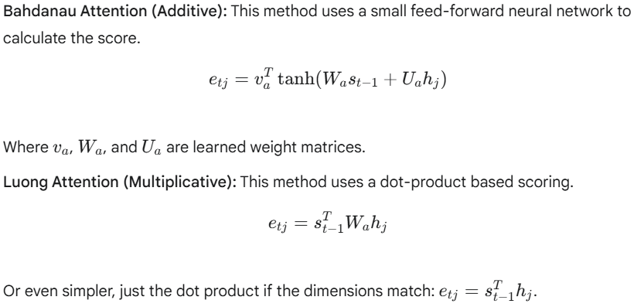

#### **Step 2: Convert Scores to Probabilities (Softmax)**

The alignment scores tell us the relative importance of each input word. To turn these scores into a probability distribution, we apply the **softmax** function. The resulting values are the **attention weights**, denoted as αtj​. Each weight is between 0 and 1, and the sum of all weights is 1.

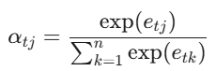

#### **Step 3: Compute the Context Vector**

The context vector for the decoder at time step *t*, denoted as ct​, is computed as the **weighted sum** of all the encoder hidden states, using the attention weights we just calculated.

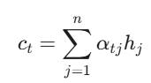

This context vector ct​ is dynamic. If αt3​ is high, it means the third word of the input is very important for generating the *t*-th output word, and the context vector ct​ will be heavily influenced by the encoder hidden state h3​.

#### **Step 4: Generate the Final Output**

Finally, the dynamic context vector ct​ is concatenated with the decoder's hidden state from the previous step (st−1​) and fed into a feed-forward neural network to produce the final output token for the current time step, y^​t​. This new output is then used to update the decoder's hidden state to st​ for the next step.

### 

<https://erdem.pl/2021/05/introduction-to-attention-mechanism>

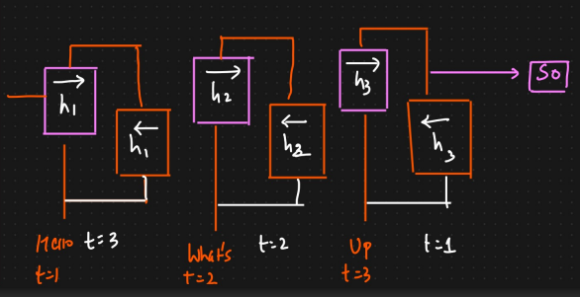

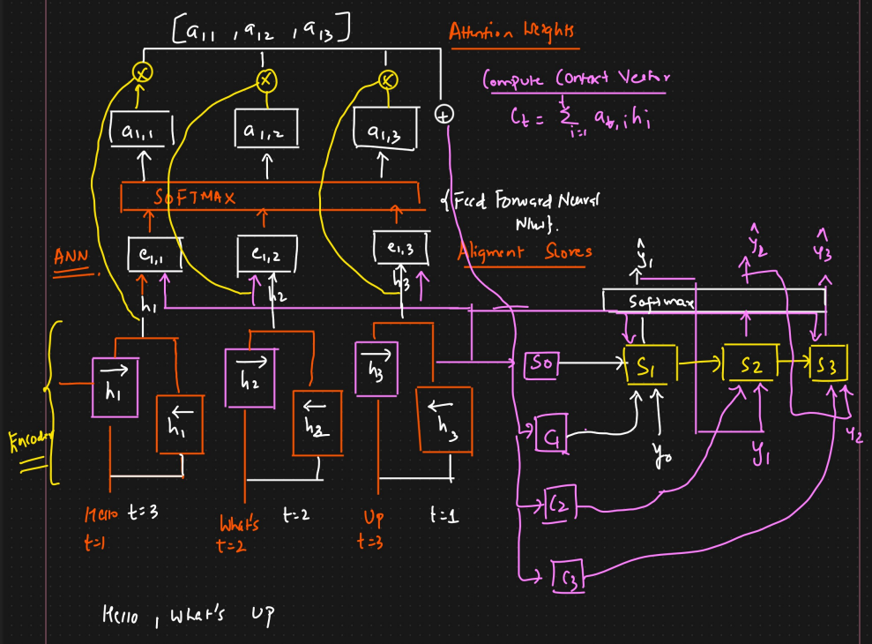

### **4. Beyond Seq2Seq: Self-Attention and the Transformer**

The concept of attention proved to be so powerful that it was extended further. A pivotal development was **Self-Attention** (also known as intra-attention).

In self-attention, the attention mechanism is applied to the **same sequence**, not between two different sequences (like an encoder and a decoder). It allows each word in a sequence to look at all other words in the same sequence to compute a new, contextually-rich representation for itself.

This idea is the fundamental building block of the **Transformer architecture**, which was introduced in the paper "Attention Is All You Need." The Transformer model completely discards the recurrent structure of RNNs and relies solely on self-attention mechanisms to process sequences. This has two major advantages:

1. **Capturing Complex Dependencies:** It can capture long-range dependencies within a sequence more effectively than RNNs.
2. **Parallelization:** Since there is no recurrent dependency on the previous time step's computation, the calculations for all words in a sequence can be performed in parallel, making it significantly faster to train on modern hardware like GPUs.

The Transformer, powered by self-attention, has become the state-of-the-art architecture for a vast majority of NLP tasks, including machine translation (Google Translate), language modeling (GPT-3, BERT), and text summarization.

### **5. Summary of Advantages of the Attention Mechanism**

* **Overcomes the Information Bottleneck:** It allows the model to access all parts of the input sequence at any time, eliminating the need to cram all information into a single vector.
* **Improved Performance:** Drastically improves performance on long sequences for tasks like machine translation.
* **Provides Interpretability:** The attention weights (αtj​) can be visualized, showing which parts of the input the model is focusing on when generating a particular output. This provides valuable insight into the model's decision-making process.
* **Paved the Way for Transformers:** The core idea of attention led to the development of self-attention and the highly successful Transformer architecture.